**Week-6 Hands-On Exercises**

**1.ReactJS - HOL**

**Single Page Application (SPA)**

* A SPA is a web app that loads a single HTML page and dynamically updates content as the user interacts with the app, without reloading the entire page.

**Benefits of SPA:**

* Faster loading after initial page load.
* Smooth user experience with no full-page refreshes.
* Better performance as only the required data is fetched.
* Can work offline using caching.

**React**

* **React** is a **JavaScript library** developed by Facebook for building fast and interactive user interfaces (especially SPAs).
* It uses **components** for building reusable UI blocks.
* Uses **Virtual DOM** to update only changed parts of the UI, making it fast.

**Pros of SPA**

* Fast navigation and better performance.
* Mobile-friendly and smooth UX.
* Efficient backend communication (API calls).

**Cons of SPA**

* SEO is challenging.
* Heavy initial load.
* Requires JavaScript to be enabled.

**Virtual DOM**

* A lightweight, in-memory representation of the real DOM.
* React updates the **Virtual DOM first**, compares it with the previous state (**diffing**), and updates only the changed elements in the real DOM (**reconciliation**).

**Features of React**

* Component-based architecture.
* Virtual DOM for performance.
* One-way data binding.

Reusable UI components.

Large community and ecosystem.

**Hands-On Lab Content**

Create a new React Application with the name “myfirstreact”, Run the application to print “Welcome to the first session of React” as the heading of that page.

1. To create a new React app, Install Nodejs and Npm from the following link:

<https://nodejs.org/en/download/>

1. Install Create-react-app by running the following command in the command prompt:



1. To create a React Application with the name of “myfirstreact”, type the following command:



1. Once the App is created, navigate into the folder of myfirstreact by typing the following command:



1. Open the folder of myfirstreact in Visual Studio Code
2. Open the App.js file in Src Folder of myfirstreact
3. Remove the current content of “App.js”
4. Replace it with the following:

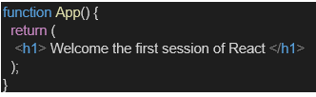

1. Run the following command to execute the React application:



1. Open a new browser window and type “localhost:3000” in the address bar.

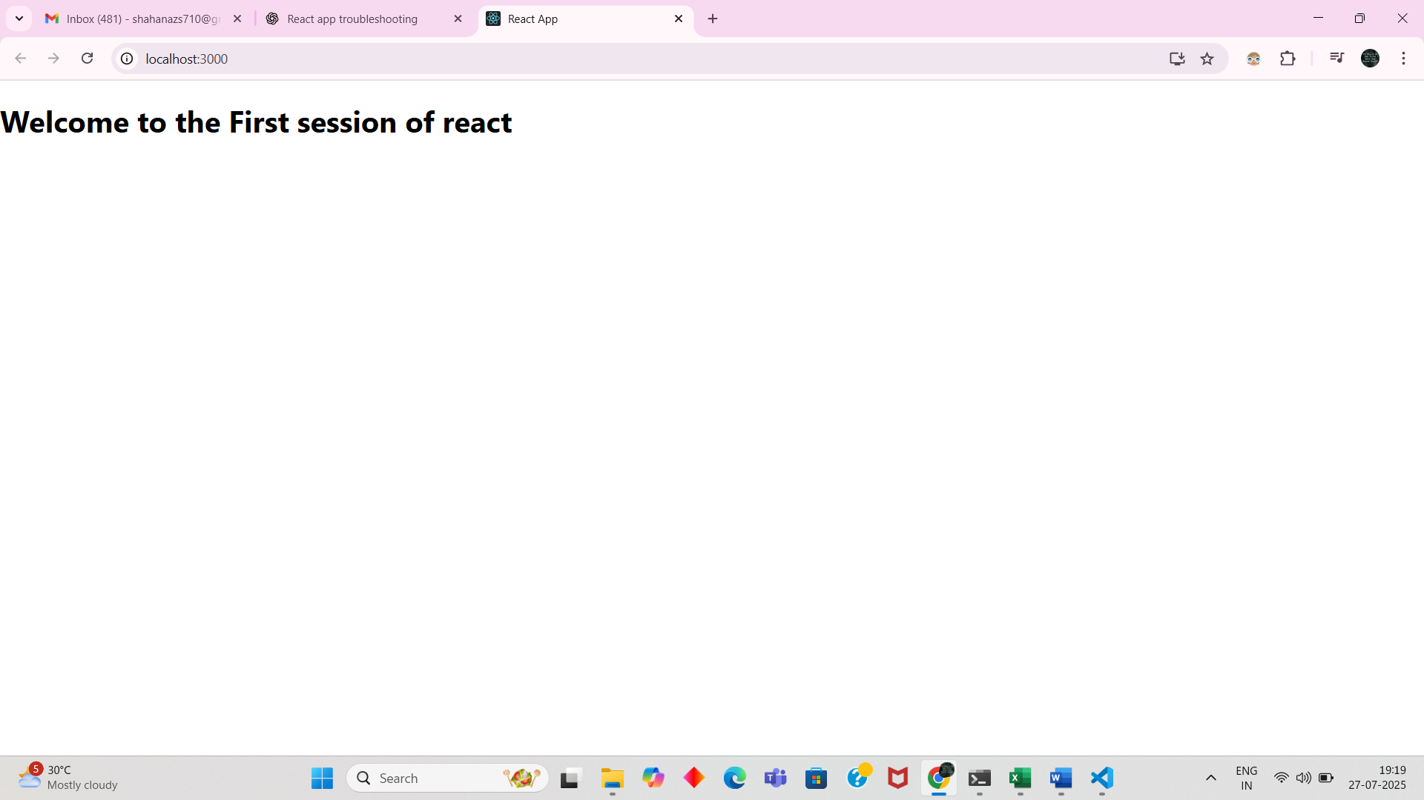

2. **ReactJS – HOL**

1. Create a React project named “StudentApp”. Type the following command in the terminal of Visual Studio:



1. Create a new folder under Src folder with the name “Components”. Add a new file named “Home.js”
2. Type the following code in Home.js

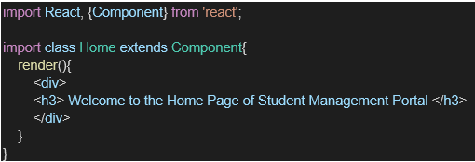

1. Under Src folder a,dd another file named “About.js”
2. Repeat the same steps for creating “About” and “Contact” components by adding a new file as ”About.js”, “Contact.js” under the “Src” folder, and edit the code as mentioned for the “Home” Component.
3. Edit the App.js to invoke the Home, About, and Contact components as follows:

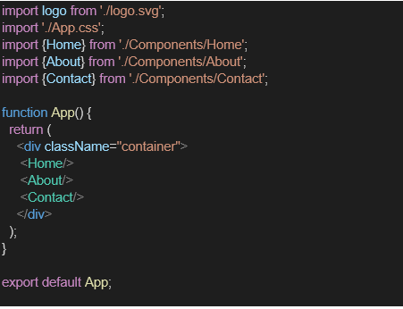

1. In command Prompt, navigate into StudentApp and execute the code by typing the following command:



1. Open browser and type “localhost:3000” in the address bar:

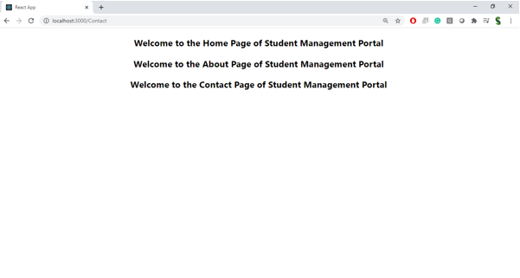

**3. ReactJS-HOL**

1. Create a React project named “scorecalculatorapp” type the following command in the terminal of Visual Studio:



1. Create a new folder under Src folder with the name “Components”. Add a new file named “CalculateScore.js”
2. Type the following code in CalculateScore.js

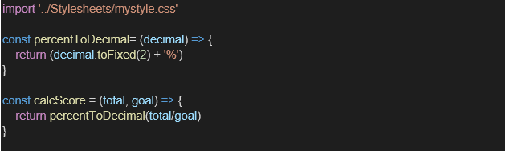

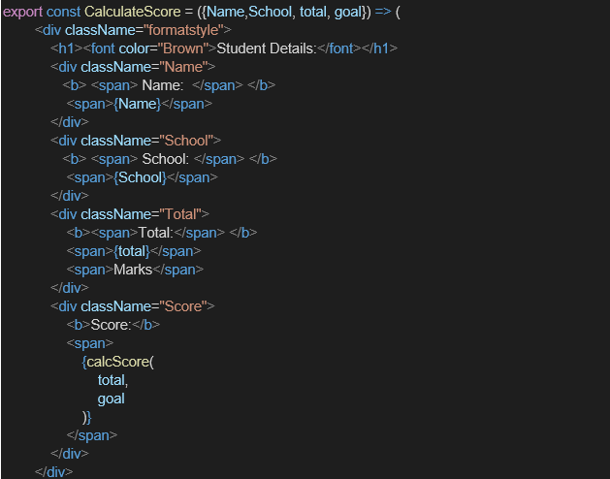

1. Create a Folder named Stylesheets and add a file named “mystyle.css” in order to add some styles to the components.

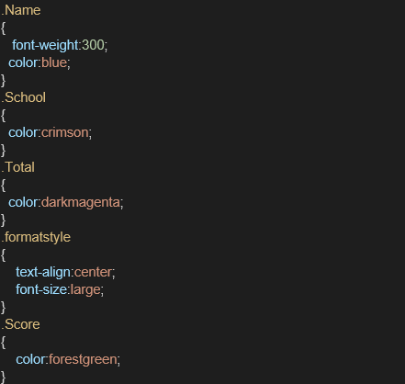

1. Edit the App.js to invoke the CalculateScore functional component as follows:

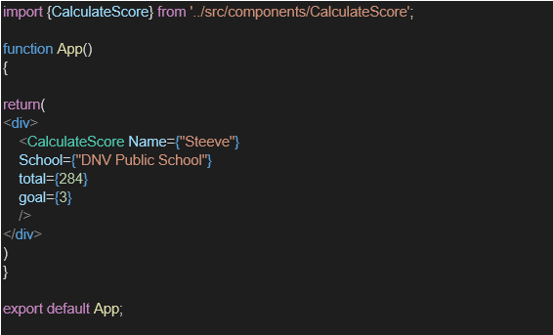

1. In command Prompt, navigate into scorecalculatorapp and execute the code by typing the following command:



1. Open the browser and type “localhost:3000” in the address bar:

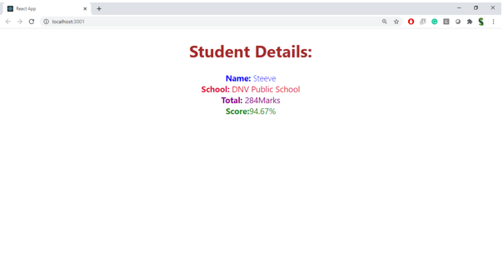

**4. ReactJS-HOL**

**App.js**

import React, { useState } from "react";

function App() {

const [posts] = useState([

{ id: 1, title: "Welcome to My App", body: "This is my own custom content instead of lorem ipsum." },

{ id: 2, title: "React is Awesome", body: "I'm learning React and customizing my app." },

{ id: 3, title: "Next Steps", body: "I will connect this app to my own backend or API soon." }

]);

return (

<div style={styles.container}>

<h1 style={styles.heading}>My Posts</h1>

{posts.map((post) => (

<div key={post.id} style={styles.card}>

<h2 style={styles.title}>{post.title}</h2>

<p style={styles.body}>{post.body}</p>

</div>

))}

</div>

);

}

const styles = {

container: {

fontFamily: "Arial, sans-serif",

maxWidth: "600px",

margin: "40px auto",

padding: "20px"

},

heading: {

textAlign: "center",

color: "#333"

},

card: {

background: "#f9f9f9",

padding: "15px",

marginBottom: "10px",

borderRadius: "8px",

boxShadow: "0 2px 4px rgba(0,0,0,0.1)"

},

title: {

margin: "0 0 5px 0",

color: "#222"

},

body: {

margin: 0,

color: "#555"

}

};

export default App;

**Steps to Run the App:**

1. Create a React project using:

npx create-react-app my-app

cd my-app

1. Replace the code inside src/App.js with the above code.
2. Start the development server:

npm start

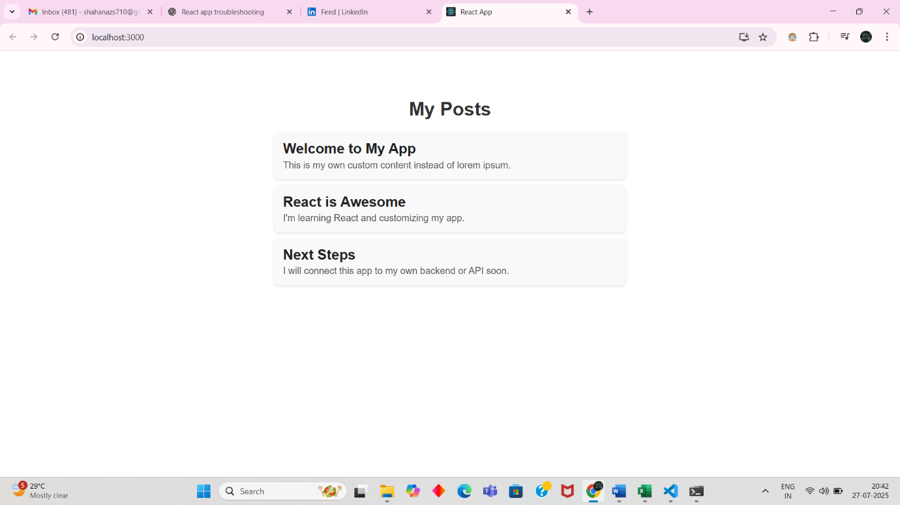

**5.ReactJS-HOL**

**CohortDetails.module.css**

.box {

width: 300px;

display: inline-block;

margin: 10px;

padding: 10px 20px;

border: 1px solid black;

border-radius: 10px;

}

dt {

font-weight: 500;

}

**CohortDetails.js**

import React from 'react';

import styles from './CohortDetails.module.css';

const CohortDetails = ({ cohort }) => {

return (

<div className={styles.box}>

<h3 style={{ color: cohort.status === 'ongoing' ? 'green' : 'blue' }}>

{cohort.name}

</h3>

<dl>

<dt>Status:</dt>

<dd>{cohort.status}</dd>

<dt>Start Date:</dt>

<dd>{cohort.startDate}</dd>

<dt>End Date:</dt>

<dd>{cohort.endDate}</dd>

</dl>

</div>

);

};

export default CohortDetails;

**App.js**

**import React from 'react';**

**import CohortDetails from './CohortDetails';**

function App() {

const cohorts = [

{ name: 'React Basics', status: 'ongoing', startDate: '2025-07-01', endDate: '2025-08-01' },

{ name: 'Advanced React', status: 'completed', startDate: '2025-05-01', endDate: '2025-06-01' }

];

return (

<div>

<h1>Cohort Dashboard</h1>

{cohorts.map((cohort, index) => (

<CohortDetails key={index} cohort={cohort} />

))}

</div>

);

}

export default App;

**Starting the App:**

npm start

